Maths Apps for iPad:
Strand | App | Icon | Link for iOS | Description
Multiple Strands | Splash Math | 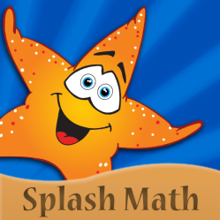 | https://itunes.apple.com/us/app/1st-grade-math-splash-math/id463469532?mt=8 | Splash Math is a fun way of practising maths and is available for grades 1 – 5. It contains problems on a wide range of maths skills, provides positive feedback to the use and has the facility to report back results.  Note: The full version of this app costs €7.99
Multiple Strands | King of Math | 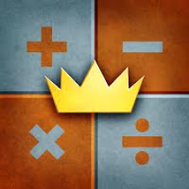 | https://itunes.apple.com/us/app/king-of-math/id473904402?mt=8&ign-mpt=uo%3D4 | King of Math is a fun game with lots of different problems in a wide range of maths areas. It allows the pupil to answer questions based on a specific topic within a time limit. Starting as a farmer, the pupil advances through the levels based on their results to eventually become the King of Math.

Number | Maths Duel | 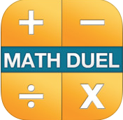 | https://itunes.apple.com/US/app/id495077699?mt=8&ign-mpt=uo%3D8 | This app covers addition, subtraction, multiplication and division with an option to turn off any of the above. Two players duel each other to answer the question as quickly as possible.
Number | Virtual Manipulatives |  | https://itunes.apple.com/ie/app/virtual-manipulatives!/id471341079?mt=8 | This app allows pupils to move around manipulatives representing fractions, decimals or percentages onto a workspace area for a range of activities. Pupils can annotate and save their work as an image for assessment.
Number | Fractions | 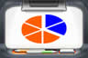 | https://itunes.apple.com/us/app/fractions-by-brainingcamp/id471353363?mt=8 | Very useful app for covering fractions, starting at very basic concepts and moving up to calculations. Includes a lesson, questions, manipulatives and a challenge.
Number | Number Pieces | 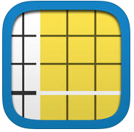 | https://itunes.apple.com/au/app/number-pieces-by-math-learning/id605433778?mt=8 | This app uses base ten blocks to enhance pupils’ understanding of number. Pupils can manipulate ones, tens and hundreds to represent number and annotate their representations to show their understanding.

Algebra | Teaching Number Lines | 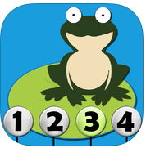 | https://itunes.apple.com/us/app/teaching-number-lines/id492603378?mt=8 | This app provides a number of activities based on number lines. Pupils use a frog to jump forwards, backwards, sequence and practice skip counting. Feedback is provided.
Algebra | Ooops | 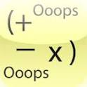 | https://itunes.apple.com/us/app/ooops/id467564672?mt=8%20 | This app allows practice of order of operations. It is designed for senior pupils and provides feedback.

Measures | Educating Eddie | 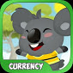 | https://itunes.apple.com/mt/app/educating-eddie-currency-learn/id663144445?mt=8 | Simple game with four different levels. Involves coin and note recognition and simple sums using euro coins. Visually appealing for younger pupils.
Measures | Ava’s Coin Game |  | https://itunes.apple.com/us/app/avas-coin-game/id355390049?mt=8 | Simple game teaching how to count money. Questions increase in difficulty as pupil progresses.
Measures | Telling Time Free | 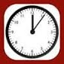 | https://itunes.apple.com/ie/app/telling-time-free/id473879314?mt=8 | Great app for checking pupils’ understanding of time. Lots of different options for modification to allow differentiation. Simple and very clear.
Measures | Scootpad | 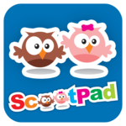 | https://itunes.apple.com/ie/app/scootpad/id557056479?mt=8 | Individual or whole class activities. Majority of topics based on: measurement, data, number, shape and space.
Measures | Room Planner |  | https://itunes.apple.com/au/app/room-planner-by-chief-architect/id520677642?mt=8 | Plan the layout of a room in 2D or 3D. Measurements of any object can be adjusted. More suitable for senior classes.

Data | Undecided | 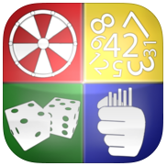 | https://itunes.apple.com/us/app/undecided/id444318521?mt=8 | Allows pupil to experiment with six different ways of testing probability including dice, paper, scissors, stone, coin toss, straws, spinner and a random number generator.
Data | BuzzMath |  | https://itunes.apple.com/ie/app/buzzmath-middle-school/id593186620?mt=8 | Strands - Data, number, algebra (mostly)  Option to track and assign assignments  Breakdown of pupil accuracy, participation, time spent and completed activities

Shape and Space | Geometry (Mathomatix) | 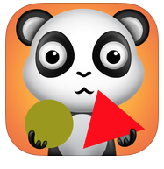 | https://itunes.apple.com/us/app/geometry-mathomatix/id429123267?mt=8 | Very cute interactive app covering five different concepts of shape. Clear spoken instructions for each activity – suitable for junior classes.
Shape and Space | Tangram XL Free | 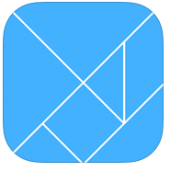 | https://itunes.apple.com/us/app/tangram-xl-free/id364592142?mt=8# | Simple tangram puzzles in a variety of levels. Pupils arrange pieces on template.
Shape and Space | Geoboard | 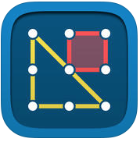 | https://itunes.apple.com/au/app/geoboard-by-math-learning/id519896952?mt=8 | Virtual geoboard where pupils can experiment with creating shapes on a variety of boards. Additional options including shading shapes,
Shape and Space | Dragon Shapes | 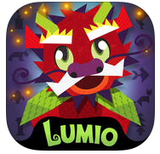 | https://itunes.apple.com/us/app/dragon-shapes-geometry-challenge/id658791693?mt=8 | Narrated story where pupils must complete shape puzzles to solve clues to find the dragon. Activities are interspersed with shape facts.

Problem Solving | Mathlands | 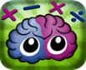 | https://itunes.apple.com/us/app/mathlands-kids-logic-game/id489905188?mt=8 | This app offers six different maths, logic and puzzle games
Problem Solving | Numbler Free | 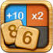 | https://itunes.apple.com/ie/app/numbler-free/id617010732?mt=8 | Scrabble with numbers. Create equations using numbers on the board. Suitable for all ages.

