Literacy apps for iPad:
Strand | App | Icon | Link | Description
Multiple Strands | Comic Life | 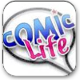 | https://itunes.apple.com/ie/app/comic-life/id432537882?mt=8 | Comic Life allows you to create a real comic with your own photos and images.
Multiple Strands | Collins Big Cat: Around the World Story Creator | 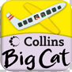 | https://itunes.apple.com/us/app/collins-big-cat-around-world/id485306015?mt=8 | This animated and interactive book allows children to bring a story to life.  Language learning is enhanced with the audio narration, music and sound effects.  The highlighting of words with narration is a strong feature.  The speaking and listening features allow children to record and listen to their own narration which enhances their speaking and listening skills. Helps to track child’s progression.
Multiple Strands | Toontastic | 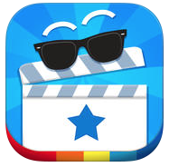 | https://itunes.apple.com/ie/app/toontastic/id404693282?mt=8 | Toontastic is a colourful, app which allows pupils to make their own cartoons. A range of backgrounds and characters are provided, but the pupils can create their own too. Pupils animate the characters and narrate the story.
Reading/Comprehension | Mr. Icky Fox | 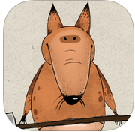 | https://itunes.apple.com/ie/app/the-icky-mr-fox/id543046969?mt=8 | Mr Icky Fox promotes strong learning and reading in young children.  The book is full of interactive objects which when activated by a child show the object's name as words and sound. Among other features of this book include professional narration, beautiful illustration and animation
Reading/Comprehension | MeeGenius - Read Along Library of Children's Books | 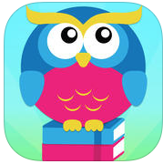 | https://itunes.apple.com/us/app/meegenius-read-along-library/id364734296?mt=8 | Your child’s imagination will be captivated by giving them access to lots of read along books. This is a library of digital books for children up to 8 years of age.  All these digital books are available with read along word highlighting, rich illustrations and story narration.
Oral Language – Listening / Speaking | Sock Puppets | 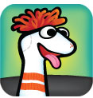 | https://itunes.apple.com/us/app/sock-puppets/id394504903?mt=8 | Sock Puppets allows the child to create their own lip-synched videos and share them via Facebook and YouTube.  Lip sync is a feature which will automatically sync the child’s voice. Start creating by adding puppets, props, scenery.  Promotes multiple users with friends working together with multiple puppets. Multiple background changes and animated puppets increase the options available to children.
Oral Language – Listening / Speaking | Rory's Story Cubes | 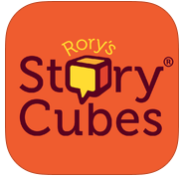 | https://itunes.apple.com/ie/app/rorys-story-cubes/id342808551?mt=8 | Contains multiple images along with 9 cubes with over 10 million different combinations and unlimited stories. Challenge a child to create a story using all 9 face-up images.
Oral Language - Poetry | Poetry Creator | 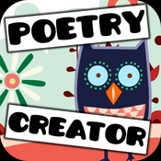 | https://itunes.apple.com/ie/app/poetry-creator-verses-poetry/id371925480?mt=8 | This app allows you to create and publish your own poetry and to share via Facebook and email.
Oral Language - Poetry | POETRY from The Poetry Foundation | 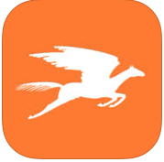 | https://itunes.apple.com/us/app/poetry-from-poetry-foundation/id370143863?mt=8 | The works of T.S. Eliot, Pablo Neruda, Lucille Clifton, Emily Dickinson, and many others are a feature of this App.  Create your own poems and save your favourites. Share your work in Facebook, Twitter and e-mail.
Writing | abc Lite Pocket phonics | 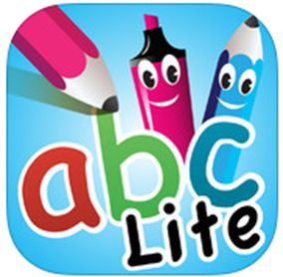 | https://itunes.apple.com/ie/app/abc-pocketphonics-lite/id302689971?mt=8 | Innovative iPhone app to enhance writing skills. Follows the UKs National Curriculum.  Makes understanding of letters easier and facilitates easier transition to reading.
Writing | Ollie’s Handwriting and Phonics | 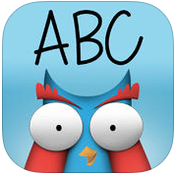 | https://itunes.apple.com/us/app/ollies-handwriting-phonics/id647784046?mt=8 | This app provides a chalk board surface for guided handwriting. It includes work on individual letters, phonics, sight words etc. Very simple but visually appealing.
Writing | Writing Prompts | 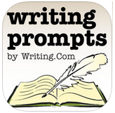 | https://itunes.apple.com/ie/app/writing-prompts/id417683378?mt=8 | Incorporating over 250 scene elements, 400 words, 60 sketches, 10 colours and over 80 genres which can generate millions of prompts for creative writing.
Spelling | Spelling Notebook Free | 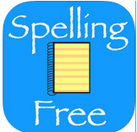 | https://itunes.apple.com/ie/app/spelling-notebook-free/id461225509?mt=8 | Personalize your spellings and practice them.  Test your spelling and hear each word spoken.  Rewarded with a star if correct and only practise the words you have yet to master.
Spelling | ABC SPELLING MAGIC | 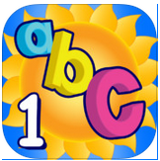 | https://itunes.apple.com/ie/app/abc-spelling-magic/id429301553?mt=8 | This app allows children to focus on the skill of learning to spell.  Three phonetic sounds with short vowel words are used to enhance skills.
Spelling | Spelling Test Free | 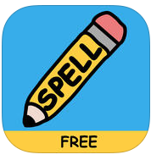 | https://itunes.apple.com/ie/app/spelling-test-free-by-funexam.com/id426041393?mt=8 | This app allows pupils or teachers to create custom spelling tests including audio. It maintains the pupils’ scores.

